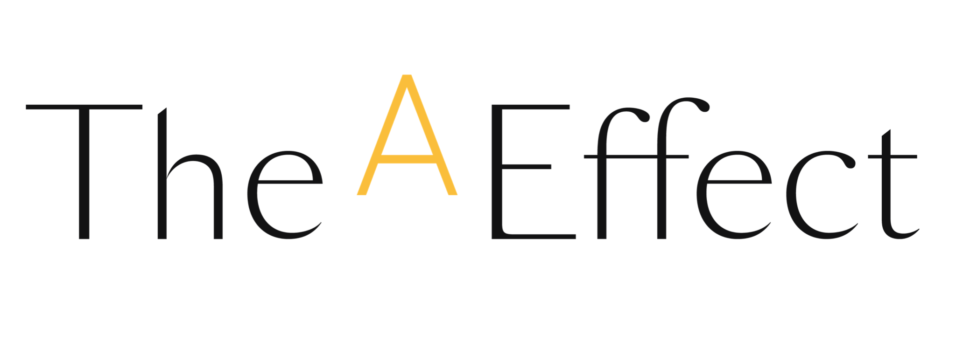

SUBJECT: Your employee is participating in The A Effect (Name of the program for which the employee was selected)

Dear (First Name),

Our company is proud to announce that it is participating in the new cohort of The A Effect (Name of the program for which the employee was selected), a renowned professional development program that helps women better demonstrate their ambition in business.

As you know, organizations face a number of issues that require, now more than ever, that they put their best available talent forward. In fact, businesses with a balanced mix of men and women at different organizational levels perform better due to a greater diversity of opinions and talents.

We’ve made it a priority to contribute to the development of our employees that demonstrate high potential. Among them, we have selected your employee (First name Last name) to take part in the upcoming cohort.

The program focuses on reshaping mindsets and adopting new behaviours with respect to confidence, risk taking and the ability to exert influence. Your role, as a manager, is a key element of this program. Here is the Candidate Guide (which includes the program schedule) and the Manager’s Guide where you will find a few simple ways to guide your employee(s), offer your support and reinforce her/their learnings.

(Optional) We’ll also share details on how to take part in the pre-launch meeting during which The A Effect team will present the program to all our participants and their managers.

If you have any questions, don’t hesitate to get in touch with me.

(Signature)

