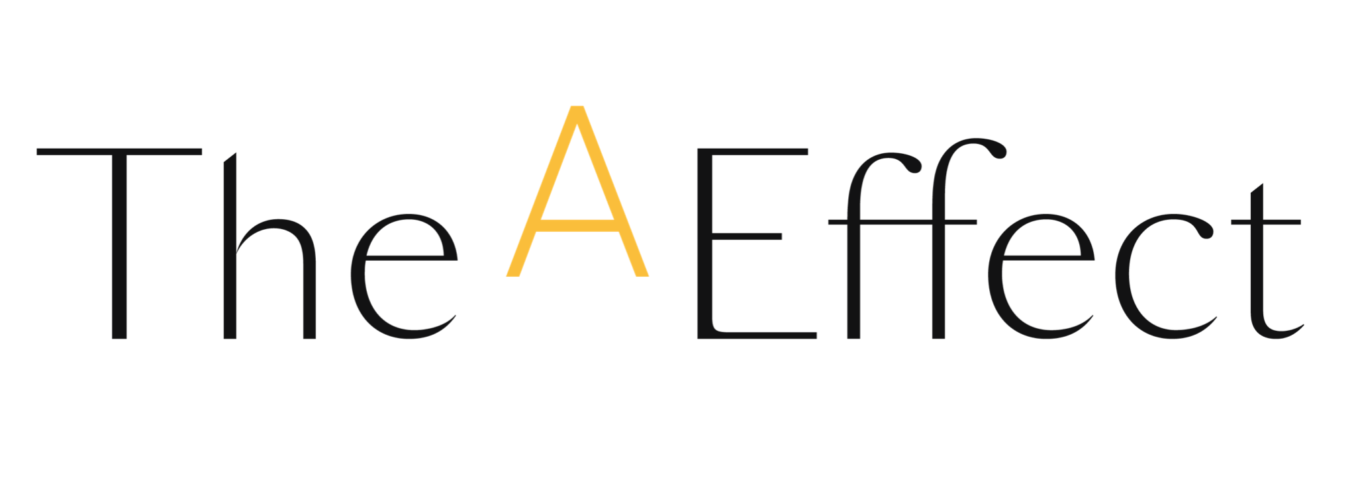

**RE: (Company name) will participate in The A Effect programs this fall 2024**

(Company name) is proud to announce our participation in The A Effect’s newest cohort, taking place this fall 2024. The A Effect designs professional development programs to propel the ambition of women in business.

(Section to be adapted: what is the context of this initiative within your organization, and what are its objectives?) As you know, the complexity of the issues faced by organizations makes it more necessary than ever to leverage the best available talents. It has been shown that companies with gender balance at all levels have better economic performance thanks to a greater diversity of opinions and talents. So, contributing to our female employees’ development is a priority for us.

The A Effect programs, available internationally in English and French, focus on the development and adoption of new behaviours.

* **Ambition Challenge / *Défi 100 jours***: to propel the careers of female talent and help them better communicate their ambition. The program is designed for all professional women with at least five years’ experience.
* **Leadership Challenge / *Défi Leadership***: to prepare middle managers to maximize their impact as team spokespersons and interpreters of organizational issues; to enhance their mastery of strategic conversations and elevate their leadership skills. The program is aimed at leaders who have been in a management role, with a team under their responsibility, for at least five years.

**Interested in participating in one of these programs during our next cohort? Are you a manager or immediate supervisor of a potential candidate?** Contact us before (deadline) to learn more about the selection criteria and registration process.

In the meantime, have a look at the [**Program Guide**](https://web.effet-a.com/hubfs/Outils%20SC/Product%20guide_The%20A%20Effect.pdf) and the [**Candidate's Guide**](https://web.effet-a.com/hubfs/Outils%20SC/TheAEffet_Candidate_Guide_Schedule_Fall.pdf), for program goals and methodology, as well as the detailed schedules.

We look forward to having you join us for this cohort and to helping you achieve your professional ambitions.

See you soon,

(Your signature)