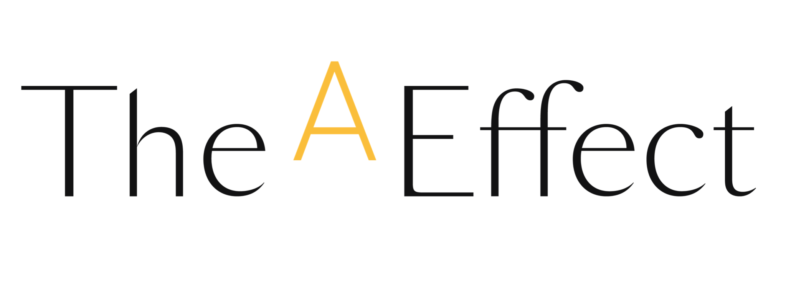

**RE: Congratulations to the new graduates of The A Effect!**

(Company name) is proud to have participated in the most recent cohort of The A Effect, which took place (this spring OR this fall). (##)(Company name) employees were selected and had the opportunity to attend the professional development programs offered by The A Effect. Introspection, risk-taking, networking, identifying and achieving a challenge, attending conferences and workshops: bravo for your journey over the past 100 days!

(Section to be adapted: how does this initiative fit into your organization, and what are your objectives?) As you know, the complexity of the issues faced by organizations makes it more necessary than ever to leverage the best available talents. It has been shown that companies with gender balance at all levels have better economic performance thanks to a greater diversity of opinions and talents. So, contributing to our female employees’ development is a priority for us.

(Optional)

**Congratulations to the new graduates of The A Effect**

* First name Last name, Job title, Department
* First name Last name, Job title, Department
* …

**A Few Words About The A Effect**   
[The A Effect](https://the-a-effect.com/) designs [professional development programs](https://web.effet-a.com/hubfs/Outils%20SC/Product%20guide_The%20A%20Effect.pdf) to boost the ambition and impact of women in business. These programs, available internationally in English and French, focus on the development and adoption of new behaviours.

* **Ambition Challenge / *Défi 100 jours***: to propel the careers of female talent and help them better communicate their ambition. The program is designed for all professional women with at least five years’ experience.
* **Leadership Challenge / *Défi Leadership***: designed for mid-level leaders who have been in a management role for at least five years, to help them transform their strategic stance in order to elevate their team and contribute to the organization's key challenges.

**Interested in participating in one of these programs during our next cohort? Are you a manager or immediate supervisor of a potential candidate?** Contact us to learn more about the selection criteria and registration process.

Once again, congratulations to each of the new graduates of The A Effect, who are joining (##) current graduates at (Company name). The past 100 days were just the beginning. Let’s continue working together to propel female talent at (Company name).

See you soon,

(Your signature)